Sri Lanka Institute of Information

Technology



Lab Submission

Lab sheet No.9

**IT23329560**

**Palihaderuarachchi W S**

**Probability & Statistics | IT2120**

B.Sc. (Hons) in Information Technology

**Exercise**

1. Assume that the time taken to bake a batch of cookies is normally distributed with mean 45 minutes and standard deviation of 2 minutes.





i) i. Generate a random sample of size 25 for the baking time.

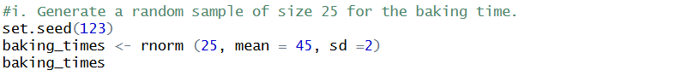

ii) ii. Test whether the average baking time is less than 46 minutes at a 5% level of significance.



